ONE MEANINGFUL GAME
CONSOLE OPERATIONS

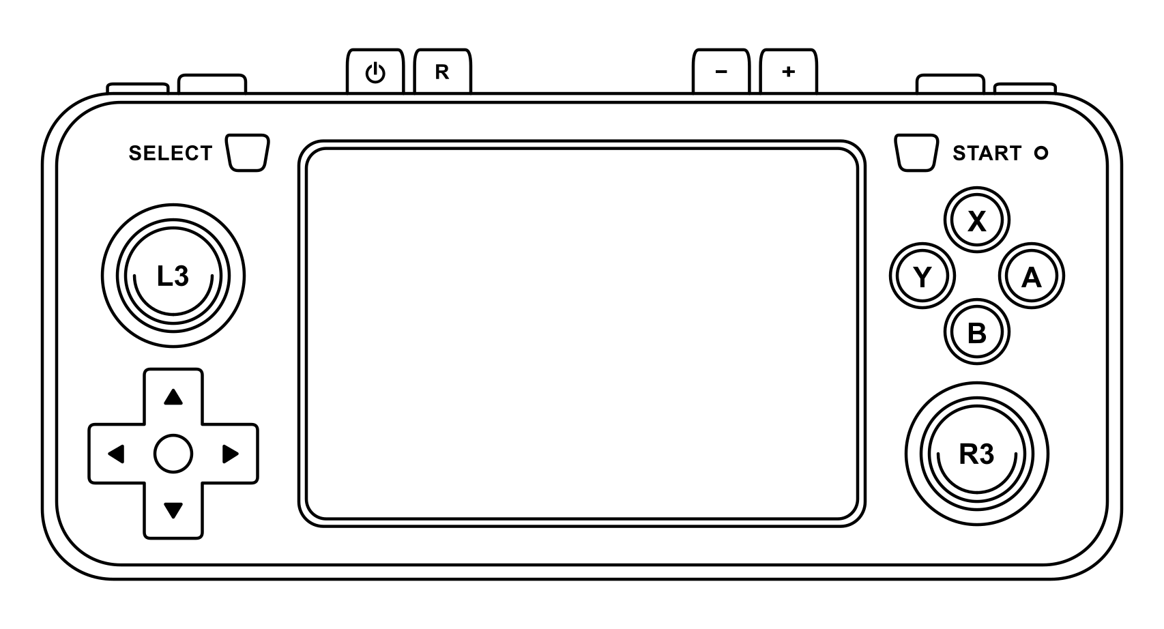

POWER ON | Press and hold the POWER button until the LED light turns green.
POWER OFF | Press the POWER button and wait until the LED light turns off. High Scores/Save Data will be saved.
RESET | Press the RESET button to reboot the console and play the next game. High Scores/Save Data WILL NOT be saved.
BATTERY | When the LED light turns red the battery level is below 30%.  Press SELECT + START to enter the Retroarch Quick Menu, the battery level will be on the top right.  Press SELECT + START to return to the game.
VOLUME | Press the - / + buttons to decrease or increase the volume.  Press and hold R3 then press L3 to mute/unmute the audio.
BRIGHTNESS | Press and hold R3 then press UP ARROW to increase the brightness and DOWN ARROW to decrease the brightness.
INSERT COIN | Press SELECT to insert a virtual coin
START | Press START to start the game
PAUSE | Press SELECT + START to pause/resume the game.

